**Data Warehouse Development**

**ETL**

For this assignment, you will use the following tutorials:

* **Create Database and Tables in SSMS: Step by step tutorial to create your own database on SSMS**
  + Hubspot_query: sql script to create required tables in your SQL database
* **SQL Server Integration Services Tutorial: step by step tutorial how to use SSIS to perform ETL** 
  + Overview_HireHeroesUSADataSets2016: data dictionary for sample data set
  + hubspot-social-media-export-01-08-16: operational data set

**EXERCISE**

1. complete **Create Database and Tables in SSMS** and **SQL Server Integration Services Tutorial**
2. provide name of your database
3. provide the following screen shots (figures 37, 39, 54)

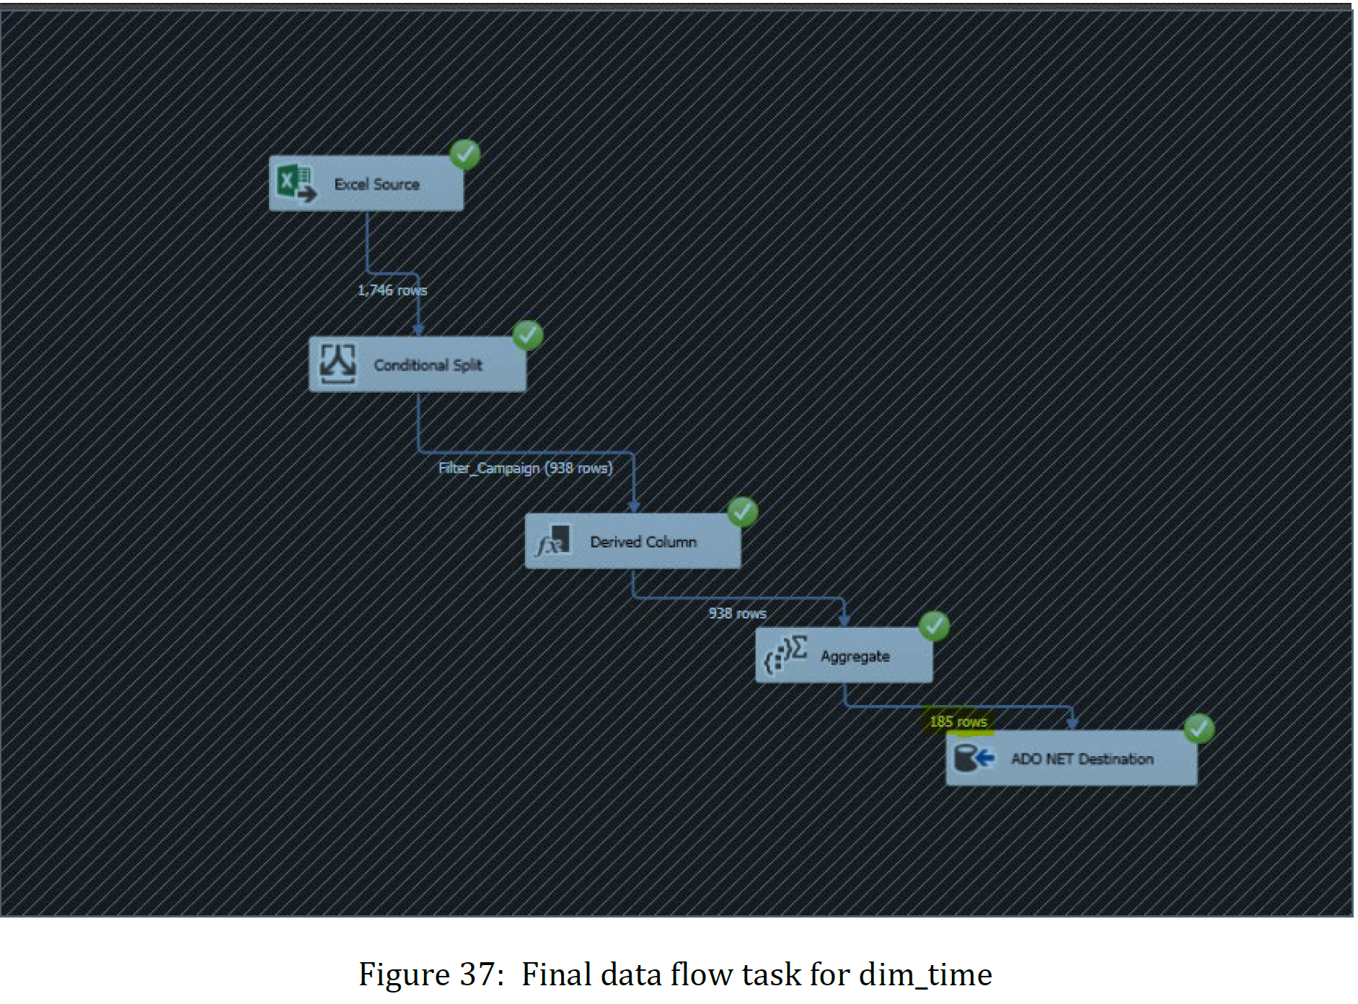

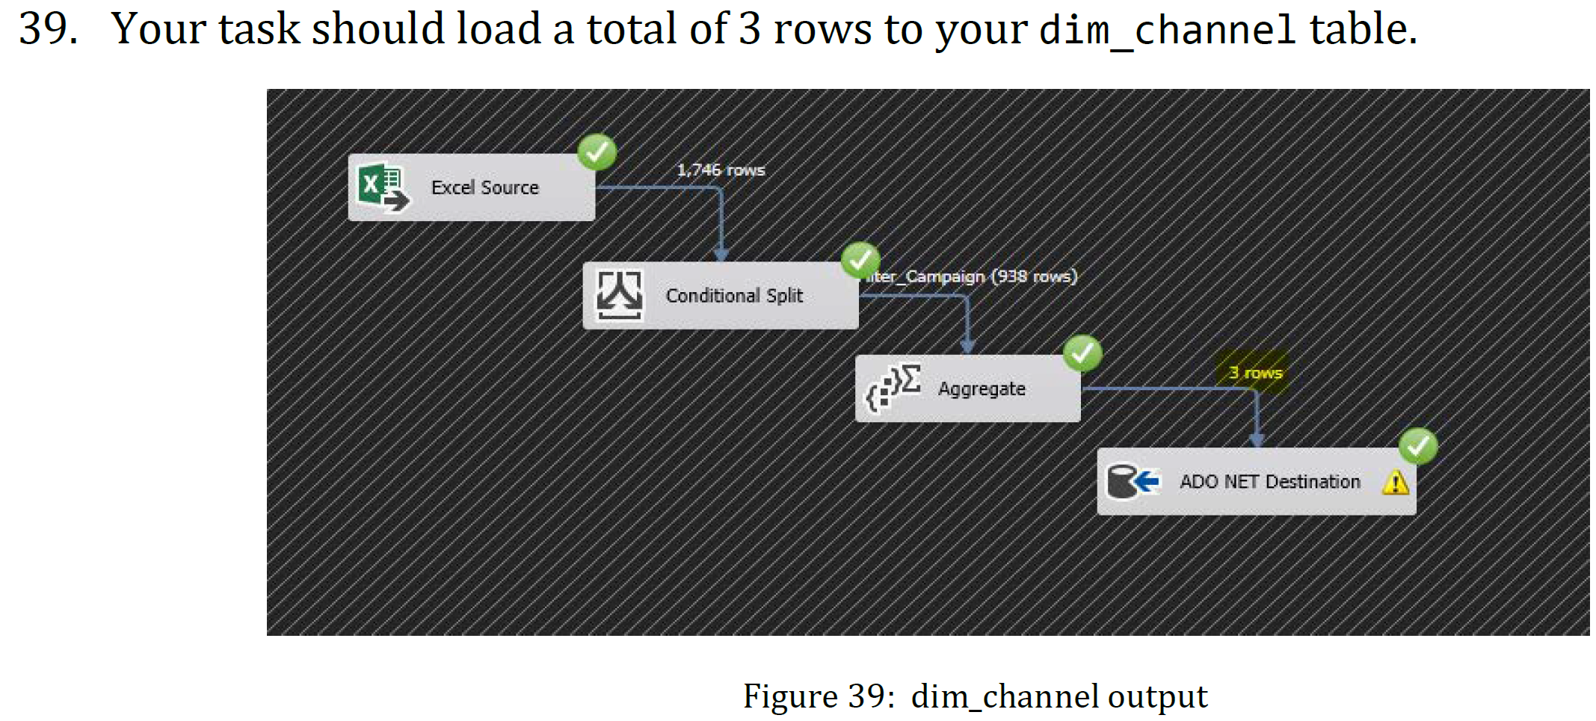

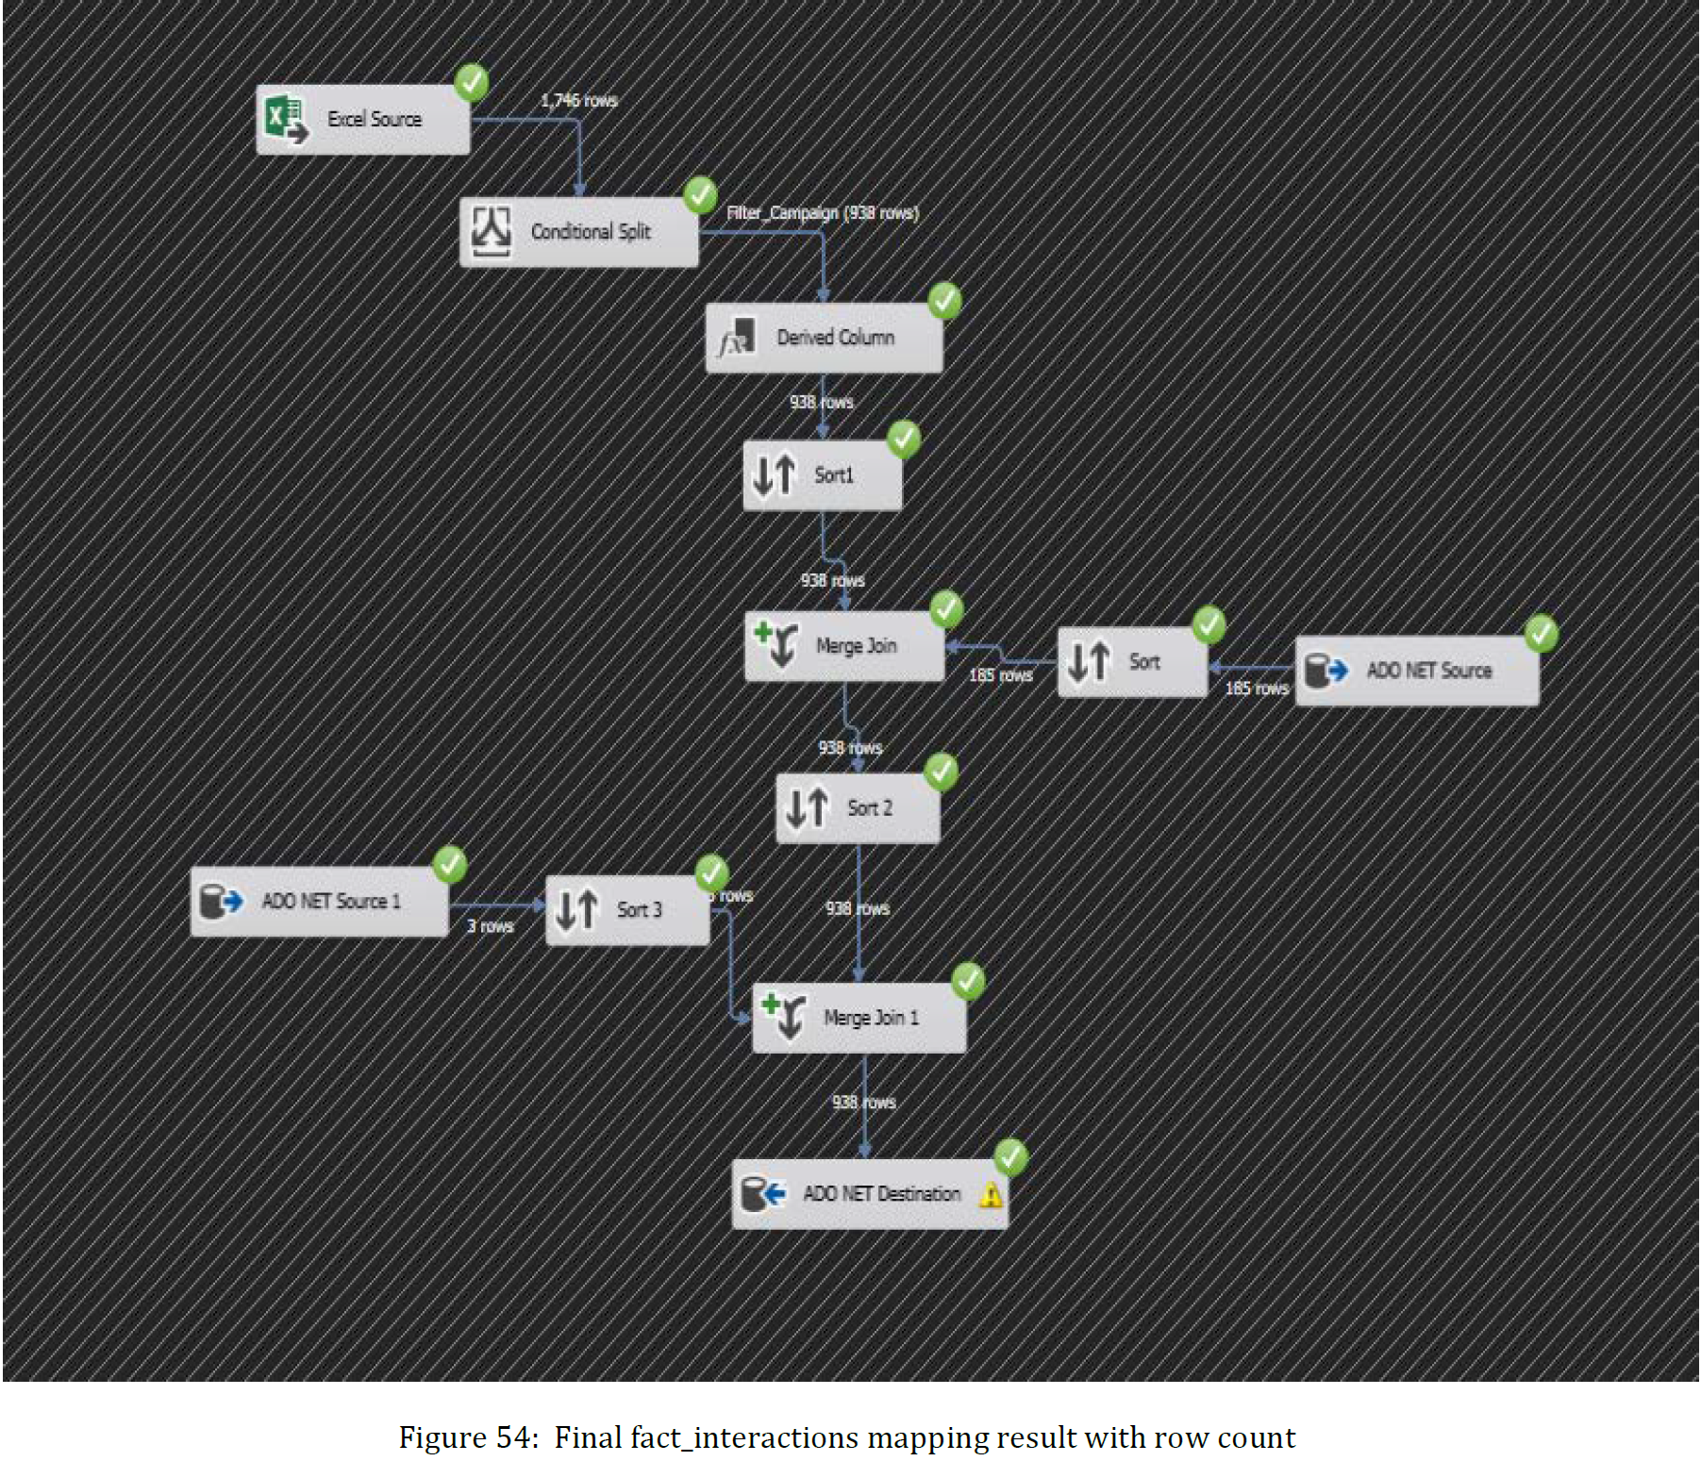

1. provide total number of row count for each table loaded are as follows
2. provide partial screen shots of your created and populated tables (dim_time, dim_channel, fact_interactions)